# HOMEWORK WEEK 1

This week’s homework will be purely Project based **+ small separate independent task (that you’ll need to complete yourself - on page below)**. You need to work as a group and the homework will be submitted by one of the members of your group. List the other members of your group in the document, so that your instructor can mark every student.

# TASK 1 (Project, as a Group)

1. Your group needs to decide what kind of project you are going to work on and lock in your decision.

We want to work on supporting mental health wellbeing.

1. You need to submit a free style paper that describes your project on a high level. Please cover the following questions:
   1. **What are you building?**

**A web application for song selection. This specifically focused on stress management as receptive music therapy.**

**We are distinguishing between 2 genres for relaxation and distraction, where distraction can be again distinguished in 2 groups: Dance Mode and Karaoke Mode.**

* 1. **What does it do or what kind of problem does it solve?**

**It aims to help managing stress in stressful situations through selected music playlist.**

* 1. **What are the key features of your system?**

**Selection of music through an API to spotify based on user needs.**

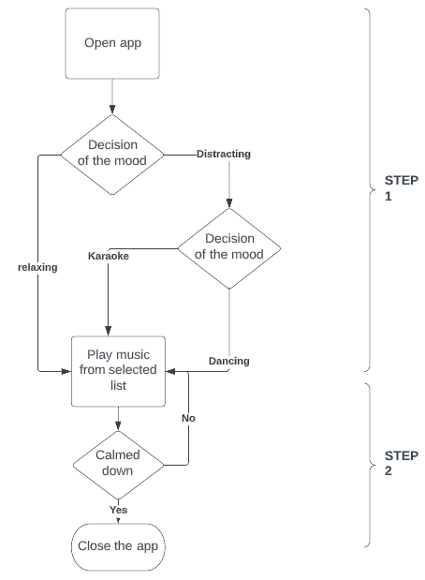

* 1. **Provide a sample architecture diagram of your system** (you can use PPT with squares and circles to demonstrate a simplified flow of your system) For example:
     1. *This doesn’t need to be anything design-based; rather, just an architectural overview of your system (will it be 1-page or multiple? Will they interact with each other? Are you going to store anything? Just a technical perspective instead of a human one to your project).*

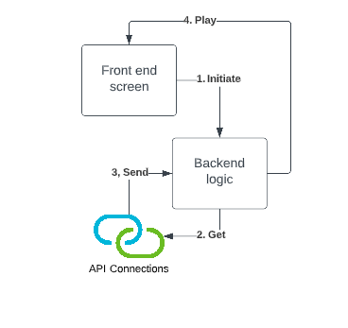

* 1. **Describe the team approach to the project work**: how are you planning to distribute the workload, how are you managing your code, how are you planning to test your system.

We will use shareable tools:

* Google Docs for report & homework
* doc for Project management
* Github repo for submission
* Lucidchart for Diagrams/Wireframes

1. Wireframes & Testing
2. Decide on possible Unit tests
3. Front end development based on wireframes
4. Create the playlists
5. Backend Logic: For song selection and calling the API

29.04.2022 To Dos

* reflect on whether we are missing something
* find out how to create shred repo
* Sunday 8pm CET 7pm UK Time Hand in